**Cognos (Office Depot) Reports**

* **Through Python Script:**
* **Prerequisites: Downloaded XML for the reports**
* **On Metadata Extraction through Python Code:**
* Ran the code for the Metadata Extraction considering the XML files for the Cognos report shared.
* Parsed and got the following data from XML.
* **Model Path:** This refers to the location or path within the IBM Cognos framework where a specific report or data model is stored.
* **Query Name:** In Cognos, a query is a request for data from a data source or data model.
* **Data Item Name:** A data item in Cognos represents a specific piece of data or a calculation within a query. Data items can be columns from a database table, calculated fields, or other data elements used in a report.
* **Expression corresponding to query:** An expression in Cognos is a formula or calculation defined within a query to manipulate or transform data.
* **Data Objects:** Data objects in Cognos represent various elements in a data model, such as tables, columns, and relationships.
* **Pages:** Pages refer to the different sections or components of a report layout
* **Through Cognos API:**
* **Set up needed to run the Crystal reports APIs:**
* A user account on IBM Cognos Analytics site with proper access.
* **Inputs needed to run the APIs:**
* Reference link: <https://www.ibm.com/docs/en/cognos-analytics/12.0.0?topic=api-getting-started-rest>
* For Authentication API, one need to have the following things as input:
* **BaseURl:** http://<cognos_analytics_server>/api/v1/
* **CAMNamespace:** The namespace or directory service used for authentication in IBM Cognos.
* **CAMUsername:** The username or identifier for an IBM Cognos user within the specified namespace.
* **CAMPassword:** The password associated with the CAMUsername to authenticate a user in IBM Cognos.   
  **OR**
* **CAMAPIloginkey:** A key or token used for authentication and authorization when accessing the Cognos API.
* The body section depends on the [**Authentication Provider**](https://www.ibm.com/docs/en/cognos-analytics/12.0.0?topic=developer-authentication-providers).
* Authentication providers give access to authentication sources.
* IBM Cognos software supports the following authentication providers:
* IBM Cognos Series 7 namespaces
* LDAP version 3 directory servers
* Microsoft Windows native security (NTLM)
* SAP BW
* Active Directory Server
* Computer Associates eTrust SiteMinder (with LDAP and/or NTLM user directories)
* **Level of access to run the APIs:**
* Access permissions determine a user's ability to perform a specific action or access a feature or object.
* **Read:** Includes the read and traverse granular permissions.
* **Run:** Includes the read, execute, and traverse granular permissions.
* **Write:** Includes the read, write, execute, and traverse granular permissions.
* **Full:** Includes the read, write, execute, traverse, and set policy granular permissions.
* We can check the permission for the report by checking the properties section from the 3 dots as follows:   
  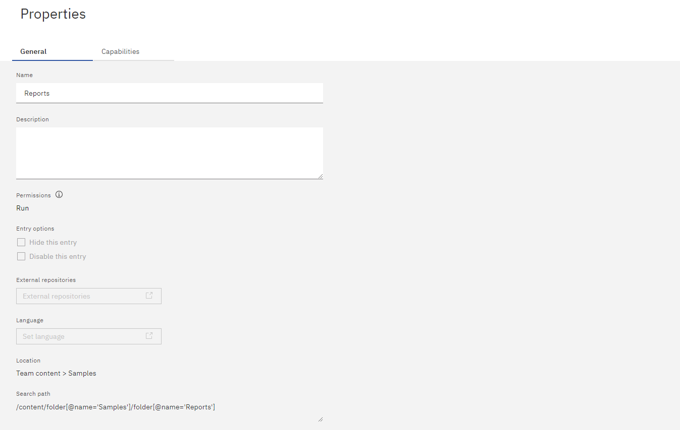
* We can see the groups and roles of the person from profile settings:   
  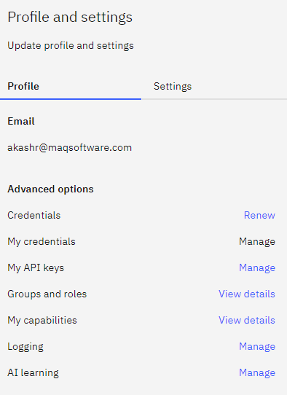   
     
  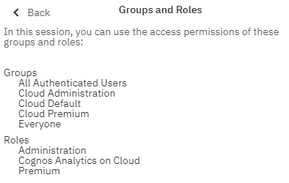
* **Cognos Reports:**
* File Extension - (.cgn or .cgf)
* **Reference Link:**
* IBM Cognos Analytics Documentation for reference:   
  [**https://www.ibm.com/docs/en/cognos-analytics/12.0.0**](https://www.ibm.com/docs/en/cognos-analytics/12.0.0)
* **Rest API:** [**https://www.ibm.com/docs/en/cognos-analytics/12.0.0?topic=api-rest-reference**](https://www.ibm.com/docs/en/cognos-analytics/12.0.0?topic=api-rest-reference)
* **Reference Link:** [**https://www.youtube.com/watch?v=-BBxcJlBynI**](https://www.youtube.com/watch?v=-BBxcJlBynI)
* **Sample Cognos Reports:**
* Started free trial on IBM Cognos Analytics Cloud:    
  <https://www.ibm.com/account/us-en/>
* On Launching it, were able to see the sample reports, data, dashboards, and base samples based on different versions:   
  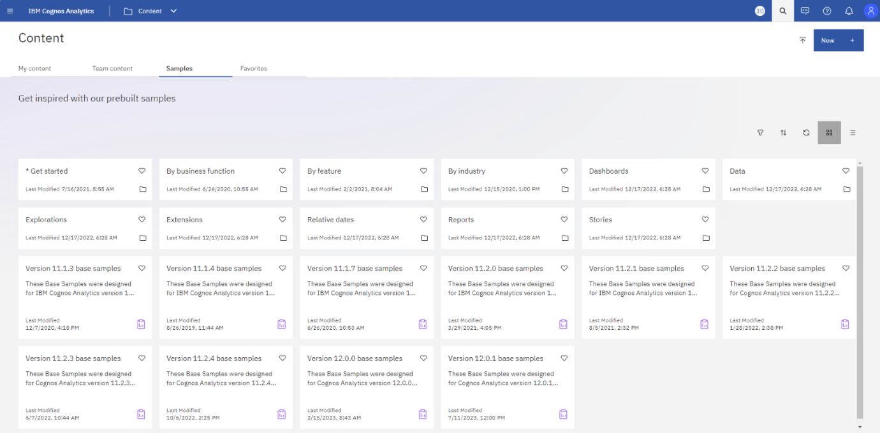   
     
  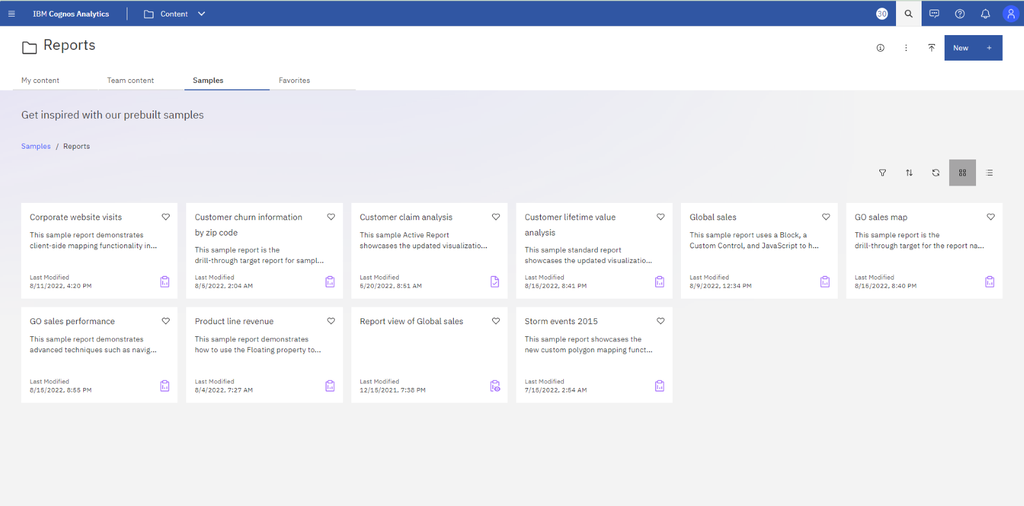   
  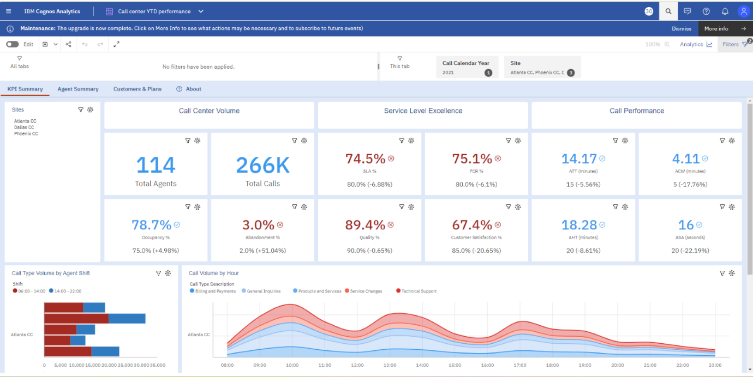   
     
  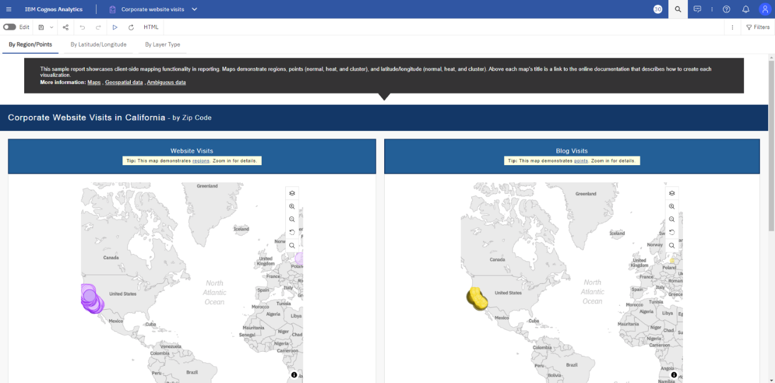

* **Metadata API:**
* Link: [**https://www.ibm.com/docs/en/cognos-analytics/12.0.0?topic=api-rest-reference**](https://www.ibm.com/docs/en/cognos-analytics/12.0.0?topic=api-rest-reference)
* **Session Key Authentication API:**
* **PUT:** http://<cognos_analytics_server>/api/v1/session
* With following JSON as body   
  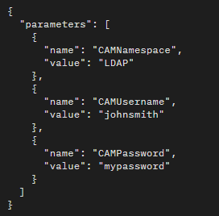
* Depending on the authentication provider you are using, the /session endpoint may not allow you to authenticate with a password. In this case, you will need to use an API login key:   
  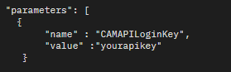
* On successful creation of session, it will return the session_key in response, using which we can Authorize the below:   
  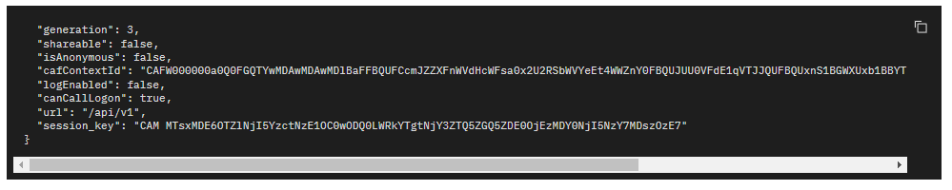   
     
  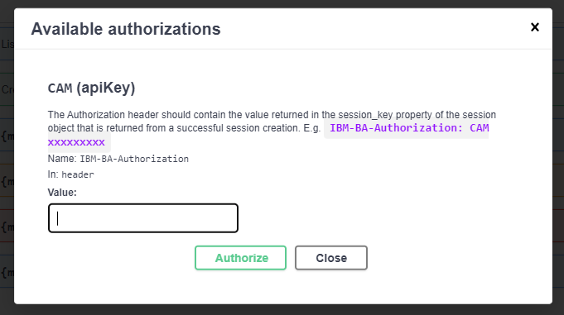
* Tried hitting the above API key with sample base URL:   
  **sample base URL:** https://us3.ca.analytics.ibm.com/bi   
  **response:**   
  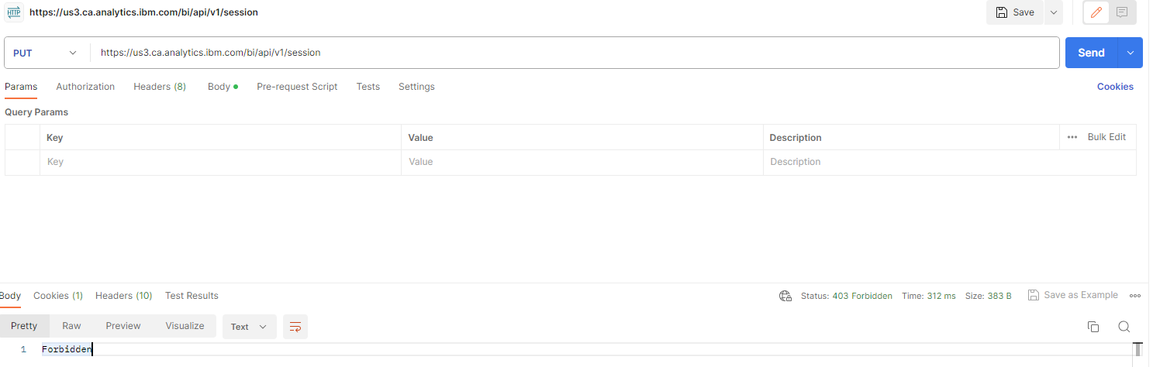
* **Security API:**
* Operations on tenants:   
  **GET:** http://<cognos_analytics_server>/api/v1/tenants   
  **Response:**   
  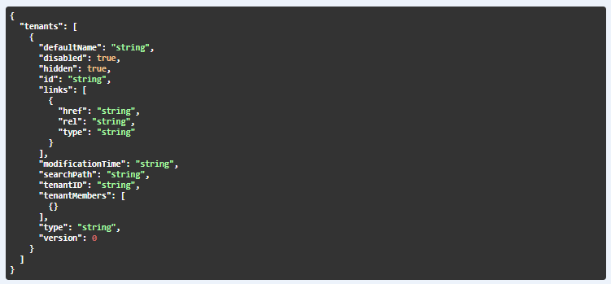
* **DataSource API:**
* List of all existing Data Sources   
  **GET:** http://<cognos_analytics_server>/api/v1/datasources   
  **Response:**   
  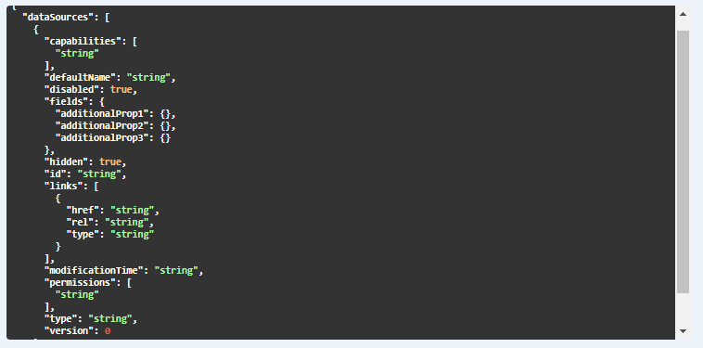

* **Connection API:**
* Getting list of existing connections for a given DataSource id   
  **GET:** http://<cognos_analytics_server>/api/v1/datasources{datasourceid}/connections   
  **Response:**   
  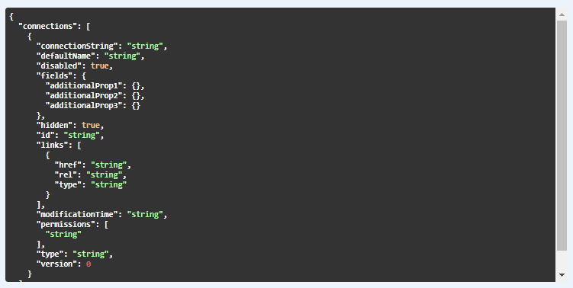
* **Signons API:**
* Getting list of all existing signons for given connection and datasource id   
  **GET:** http://<cognos_analytics_server>/api/v1//datasources/{datasourceid}/connections/{connectionid}/signons   
  **Response:**   
  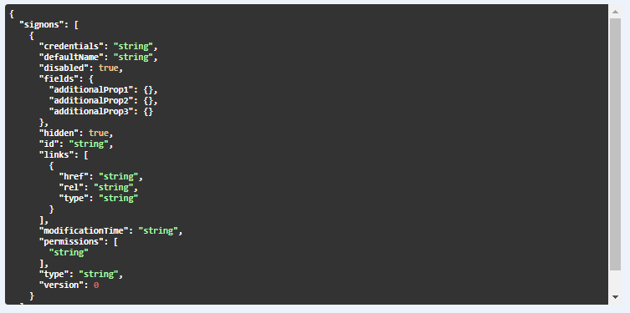
* **Schema API:**
* Getting list of all schemas for given connection id, datasource id, and signon id:   
  **GET:** http://<cognos_analytics_server>/api/v1//datasources/{datasourceid}/connections/{connectionid}/signons/{signonid}/schemas   
  **Response:**   
  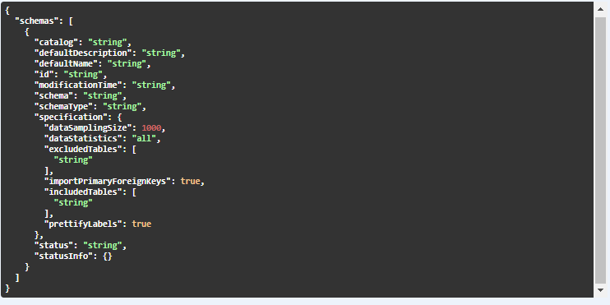
* **Tables API:**
* Getting list of all tables for given datasource id, connection id, signon id, and schema id:   
  **GET:** http://<cognos_analytics_server>/api/v1//datasources/{datasourceid}/connections/{connectionid}/signons/{signonid}/schemas/tables   
  **Response:**   
  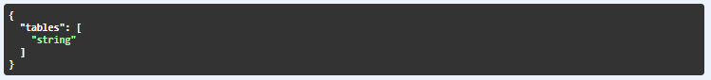
* **Modules API:**
* Getting list of all modules:   
  **GET:** http://<cognos_analytics_server>/api/v1/modules   
  **Response:**   
  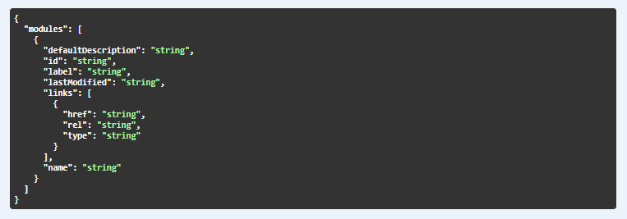
* Getting metadata for a module   
  **GET:** http://<cognos_analytics_server>/api/v1//modules/{moduleid}/metadata
* **Files API:**
* Getting list of all files:   
  **GET:** http://<cognos_analytics_server>/api/v1/files   
  **Response:**   
  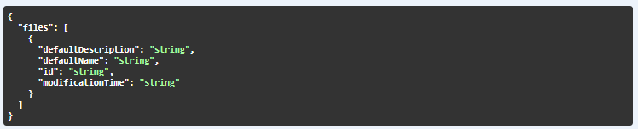
* **Metadata Analysis:**

|  |  |
| --- | --- |
| **Metadata Based on Workbooks** | **Fetched or Not** |
| Reports | Yes |
| Pages | Yes (From Script) |
| Measures | No |
| Tables | Yes |
| Columns | Yes (From Script but its present in Query) |
| Joins | No |
| Relationships | No |
| Hierarchy | No |
| Filter | No |
| DataSource | Yes |